General Curve Tangency
# Source: AI Source: Provided by: [Data Path: Persons Table -> ID Column: 1, Name_En Column: Motasem Essam] -> From: [ChatGPT] on [7/25/2026]
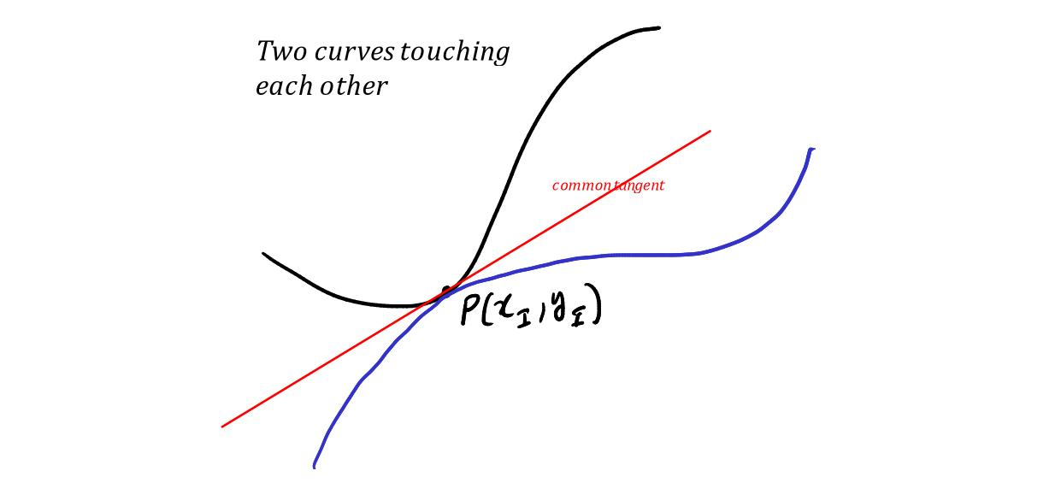
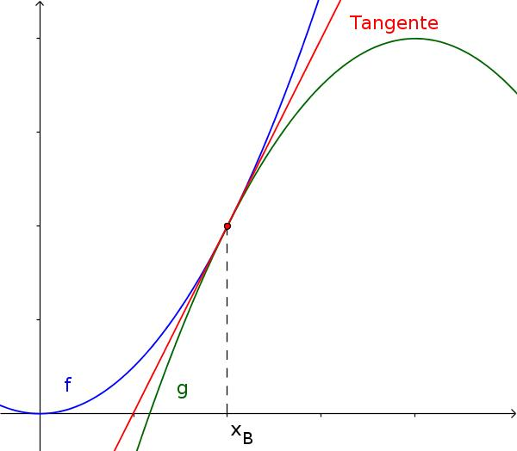
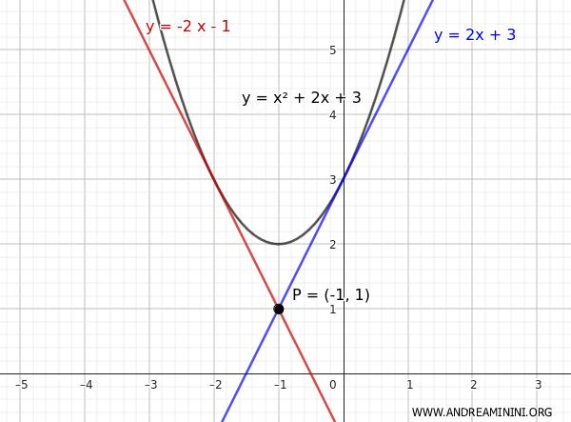
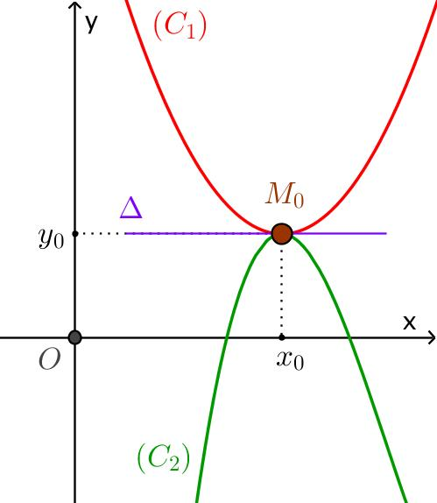

Definition
# Source: AI Source: Provided by: [Data Path: Persons Table -> ID Column: 1, Name_En Column: Motasem Essam] -> From: [ChatGPT] on [7/25/2026]
General Curve Tangency is a type of Curve–Curve Tangency in which two curves touch at a common point and have the same tangent line at that point.
It is the general form of curve–curve tangency and does not require the curves to be circles, polygons, or any other particular geometric shapes.
The common point is called the point of tangency.

Fundamental Concept
# Source: AI Source: Provided by: [Data Path: Persons Table -> ID Column: 1, Name_En Column: Motasem Essam] -> From: [ChatGPT] on [7/25/2026]
Let two curves be $C_{1}$and $C_{2}$, and let $T$be their common point.
For general curve tangency:
$$\boxed{T∈C_{1}∩C_{2}}$$
and the curves have the same tangent direction at $T$.
Thus:
$$\boxed{{\text{Tangent}}_{C_{1}}\left(T\right)={\text{Tangent}}_{C_{2}}\left(T\right)}$$
The curves may have completely different shapes away from $T$.

Main Parts
# Source: AI Source: Provided by: [Data Path: Persons Table -> ID Column: 1, Name_En Column: Motasem Essam] -> From: [ChatGPT] on [7/25/2026]
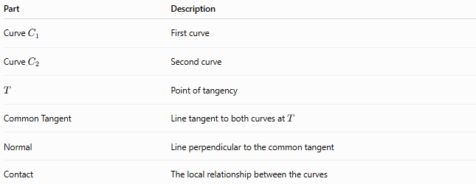
Part | Description
Curve $C_{1}$ | First curve
Curve $C_{2}$ | Second curve
$$T$$ | Point of tangency
Common Tangent | Line tangent to both curves at $T$
Normal | Line perpendicular to the common tangent
Contact | The local relationship between the curves

Basic Diagram
# Source: AI Source: Provided by: [Data Path: Persons Table -> ID Column: 1, Name_En Column: Motasem Essam] -> From: [ChatGPT] on [7/25/2026]
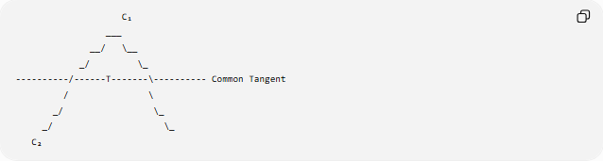
C₁
___
__/ \__
_/ \_
----------/------T-------\---------- Common Tangent
/ \
_/ \_
_/ \_
C₂
At $T$, both curves share the same tangent line.
The key relationship is:
$$\boxed{\text{Same point}+\text{Same tangent direction}}$$

Defining Conditions
# Source: AI Source: Provided by: [Data Path: Persons Table -> ID Column: 1, Name_En Column: Motasem Essam] -> From: [ChatGPT] on [7/25/2026]
For two curves represented locally by:
$$y=f\left(x\right)$$
and:
$$y=g\left(x\right)$$
to be tangent at:
$$T=\left(x_{0} , y_{0}\right)$$
the basic conditions are:
Common Point
$$\boxed{f\left(x_{0}\right)=g\left(x_{0}\right)}$$
Common Tangent Slope
$$\boxed{f^{'}\left(x_{0}\right)=g^{'}\left(x_{0}\right)}$$
Together:
$$\boxed{f\left(x_{0}\right)=g\left(x_{0}\right) \text{and} f^{'}\left(x_{0}\right)=g^{'}\left(x_{0}\right)}$$

Common Tangent Line
# Source: AI Source: Provided by: [Data Path: Persons Table -> ID Column: 1, Name_En Column: Motasem Essam] -> From: [ChatGPT] on [7/25/2026]
If the common point is:
$$T=\left(x_{0} , y_{0}\right)$$
and the common slope is:
$$m=f^{'}\left(x_{0}\right)=g^{'}\left(x_{0}\right)$$
then the common tangent line is:
$$\boxed{y-y_{0}=m\left(x-x_{0}\right)}$$
This line is tangent to both curves at $T$.

Normal Line
# Source: AI Source: Provided by: [Data Path: Persons Table -> ID Column: 1, Name_En Column: Motasem Essam] -> From: [ChatGPT] on [7/25/2026]
The normal line is perpendicular to the common tangent.
If:
$$m≠0$$
then the normal slope is:
$$\boxed{m_{n}=-\frac{1}{m}}$$
and its equation is:
$$\boxed{y-y_{0}=-\frac{1}{m}\left(x-x_{0}\right)}$$
If the tangent is horizontal, the normal is vertical.

Parametric Curves
# Source: AI Source: Provided by: [Data Path: Persons Table -> ID Column: 1, Name_En Column: Motasem Essam] -> From: [ChatGPT] on [7/25/2026]
Suppose the curves are represented parametrically by:
$$r_{1}\left(t\right)$$
and:
$$r_{2}\left(u\right)$$
They are tangent at $T$when:
$$\boxed{r_{1}\left(t_{0}\right)=r_{2}\left(u_{0}\right)=T}$$
and their tangent vectors are parallel:
$$\boxed{r_{1}^{'}\left(t_{0}\right)∥r_{2}^{'}\left(u_{0}\right)}$$
Thus, the curves have the same tangent direction even if their parameterizations use different parameters.

Implicit Curves
# Source: AI Source: Provided by: [Data Path: Persons Table -> ID Column: 1, Name_En Column: Motasem Essam] -> From: [ChatGPT] on [7/25/2026]
Suppose the curves are:
$$F\left(x , y\right)=0$$
and:
$$G\left(x , y\right)=0$$
At their common point:
$$T=\left(x_{0} , y_{0}\right)$$
we require:
$$F\left(x_{0} , y_{0}\right)=0$$
and:
$$G\left(x_{0} , y_{0}\right)=0$$
For tangency, their normal vectors must be parallel:
$$\boxed{∇F\left(x_{0} , y_{0}\right)∥∇G\left(x_{0} , y_{0}\right)}$$
Since the gradient is perpendicular to the tangent line, parallel gradients imply the same tangent direction.

Geometric Interpretation
# Source: AI Source: Provided by: [Data Path: Persons Table -> ID Column: 1, Name_En Column: Motasem Essam] -> From: [ChatGPT] on [7/25/2026]
General curve tangency means that, at the point of contact, the two curves have the same first-order behavior.
Near $T$, the curves initially follow the same direction.
They may nevertheless separate from one another immediately after the contact.
Therefore:
$$\boxed{\text{Same tangent does not mean same curve}}$$
Two different curves can touch at one point and then diverge.

Example
# Source: AI Source: Provided by: [Data Path: Persons Table -> ID Column: 1, Name_En Column: Motasem Essam] -> From: [ChatGPT] on [7/25/2026]
Consider:
$$y=x^{2}$$
and:
$$y=2x^{2}$$
At:
$$x=0$$
both curves pass through:
$$T=\left(0 , 0\right)$$
Their derivatives are:
$$f^{'}\left(x\right)=2x$$
and:
$$g^{'}\left(x\right)=4x$$
Therefore:
$$f^{'}\left(0\right)=0$$
and:
$$g^{'}\left(0\right)=0$$
So they have the same tangent line:
$$\boxed{y=0}$$
Thus, the curves are tangent at the origin.

Tangency vs Ordinary Intersection
# Source: AI Source: Provided by: [Data Path: Persons Table -> ID Column: 1, Name_En Column: Motasem Essam] -> From: [ChatGPT] on [7/25/2026]
The distinction is important.
Ordinary Intersection
Two curves meet and cross:
$$\boxed{\text{Different tangent directions}}$$
Tangency
Two curves meet but have the same tangent direction:
$$\boxed{\text{Same tangent direction}}$$
No Intersection
The curves do not share a point.
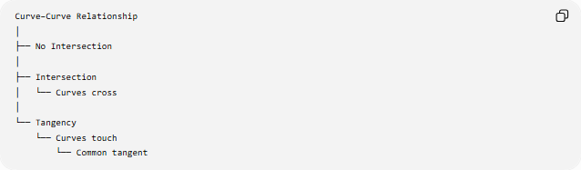
Curve–Curve Relationship
│
├── No Intersection
│
├── Intersection
│ └── Curves cross
│
└── Tangency
└── Curves touch
└── Common tangent

General Classification of Curve Tangency
# Source: AI Source: Provided by: [Data Path: Persons Table -> ID Column: 1, Name_En Column: Motasem Essam] -> From: [ChatGPT] on [7/25/2026]
General curve tangency can be organized as:
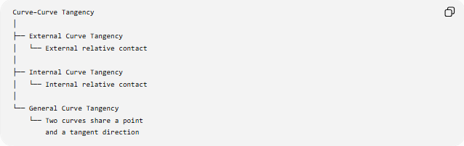
Curve–Curve Tangency
│
├── External Curve Tangency
│ └── External relative contact
│
├── Internal Curve Tangency
│ └── Internal relative contact
│
└── General Curve Tangency
└── Two curves share a point
and a tangent direction
However, there is an important mathematical distinction:
General Curve Tangency is the broad concept, while external and internal tangency are relative-position classifications that are most naturally defined for closed curves or curves with a meaningful inside/outside relationship.

General Curve Tangency vs Circle Tangency
# Source: AI Source: Provided by: [Data Path: Persons Table -> ID Column: 1, Name_En Column: Motasem Essam] -> From: [ChatGPT] on [7/25/2026]
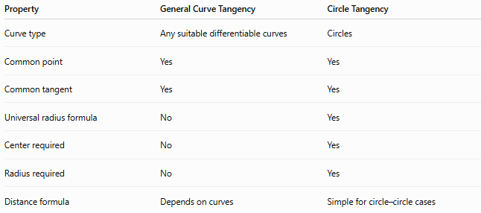
Property | General Curve Tangency | Circle Tangency
Curve type | Any suitable differentiable curves | Circles
Common point | Yes | Yes
Common tangent | Yes | Yes
Universal radius formula | No | Yes
Center required | No | Yes
Radius required | No | Yes
Distance formula | Depends on curves | Simple for circle–circle cases
For circles:
External tangency
$$\boxed{d=R_{1}+R_{2}}$$
Internal tangency
$$\boxed{d=∣R_{1}-R_{2}∣}$$
No equivalent universal formula exists for arbitrary curves.

Tangency of Two Polynomial Curves
# Source: AI Source: Provided by: [Data Path: Persons Table -> ID Column: 1, Name_En Column: Motasem Essam] -> From: [ChatGPT] on [7/25/2026]
For two functions:
$$y=f\left(x\right)$$
and:
$$y=g\left(x\right)$$
define their difference:
$$h\left(x\right)=f\left(x\right)-g\left(x\right)$$
If they are tangent at $x=x_{0}$, then:
$$\boxed{h\left(x_{0}\right)=0}$$
and:
$$\boxed{h^{'}\left(x_{0}\right)=0}$$
Therefore, $x_{0}$is a repeated root of the difference function under ordinary smooth conditions.
This provides an algebraic way to detect tangency.

Higher-Order Tangency
# Source: AI Source: Provided by: [Data Path: Persons Table -> ID Column: 1, Name_En Column: Motasem Essam] -> From: [ChatGPT] on [7/25/2026]
General curve tangency can involve more than just matching first derivatives.
If:
$$f\left(x_{0}\right)=g\left(x_{0}\right) \\ f^{'}\left(x_{0}\right)=g^{'}\left(x_{0}\right)$$
and:
$$f^{''}\left(x_{0}\right)=g^{''}\left(x_{0}\right)$$
then the curves also have the same second-order behavior at $T$.
More generally, if several successive derivatives agree, the curves have higher-order contact.
For example:
$$\boxed{f^{\left(k\right)}\left(x_{0}\right)=g^{\left(k\right)}\left(x_{0}\right)}$$
for several values of $k$.

First-Order vs Higher-Order Contact
# Source: AI Source: Provided by: [Data Path: Persons Table -> ID Column: 1, Name_En Column: Motasem Essam] -> From: [ChatGPT] on [7/25/2026]
Contact | Conditions
Common point | $$f\left(x_{0}\right)=g\left(x_{0}\right)$$
Tangency | First derivatives also equal
Higher-order contact | Additional derivatives also equal
Coincident curves locally | All relevant derivatives agree over a neighborhood
Thus, tangency is fundamentally a first-order contact condition.

Special Cases
# Source: AI Source: Provided by: [Data Path: Persons Table -> ID Column: 1, Name_En Column: Motasem Essam] -> From: [ChatGPT] on [7/25/2026]
General curve tangency includes many familiar geometric situations:
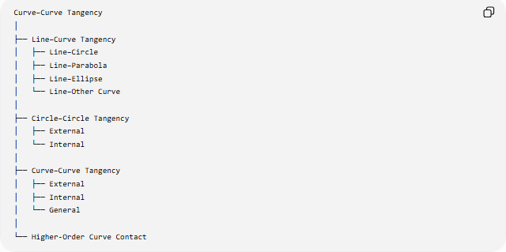
Curve–Curve Tangency
│
├── Line–Curve Tangency
│ ├── Line–Circle
│ ├── Line–Parabola
│ ├── Line–Ellipse
│ └── Line–Other Curve
│
├── Circle–Circle Tangency
│ ├── External
│ └── Internal
│
├── Curve–Curve Tangency
│ ├── External
│ ├── Internal
│ └── General
│
└── Higher-Order Curve Contact

Applications
# Source: AI Source: Provided by: [Data Path: Persons Table -> ID Column: 1, Name_En Column: Motasem Essam] -> From: [ChatGPT] on [7/25/2026]
General curve tangency is used in:
- Computer graphics
- CAD and geometric modeling
- Bézier and spline design
- Robotics
- Motion planning
- Computer-aided manufacturing
- Engineering design
- Road and track design
- Animation
- Collision detection
- Optimization
- Numerical geometry
For example, smooth transitions between two curves often require them to have a common tangent at their joining point.

Key Points
# Source: AI Source: Provided by: [Data Path: Persons Table -> ID Column: 1, Name_En Column: Motasem Essam] -> From: [ChatGPT] on [7/25/2026]
- General Curve Tangency is the broad concept of two curves touching with the same tangent direction.
- The curves must share a common point:
$$\boxed{f\left(x_{0}\right)=g\left(x_{0}\right)}$$
- Their tangent slopes must agree:
$$\boxed{f^{'}\left(x_{0}\right)=g^{'}\left(x_{0}\right)}$$
- Their common tangent is:
$$\boxed{y-y_{0}=m\left(x-x_{0}\right)}$$
- For parametric curves, tangent vectors are parallel.
- For implicit curves, gradients are parallel.
- Tangency does not require the curves to have the same shape.
- Tangency is different from ordinary intersection because the tangent directions agree.
- External and internal tangency are relative-position classifications of the general tangency concept.
- Circle–circle tangency is a particularly simple special case.

Conclusion
# Source: AI Source: Provided by: [Data Path: Persons Table -> ID Column: 1, Name_En Column: Motasem Essam] -> From: [ChatGPT] on [7/25/2026]
General Curve Tangency is the fundamental relationship in which two curves meet at a common point and share the same tangent direction at that point.
For two differentiable functions:
$$\boxed{f\left(x_{0}\right)=g\left(x_{0}\right) \text{and} f^{'}\left(x_{0}\right)=g^{'}\left(x_{0}\right)}$$
These conditions establish the essential first-order contact between the curves.
The concept is broader than circle–circle tangency and provides the mathematical foundation for tangency between lines, circles, parabolas, ellipses, splines, and other curves.

